Quantum Project:

**Muhammad Laraib Akhtar** 21L-5294**, Qasim Naveed** 21L-5231, **Aatiqa Hussain** 21L-5397

BCS-6A

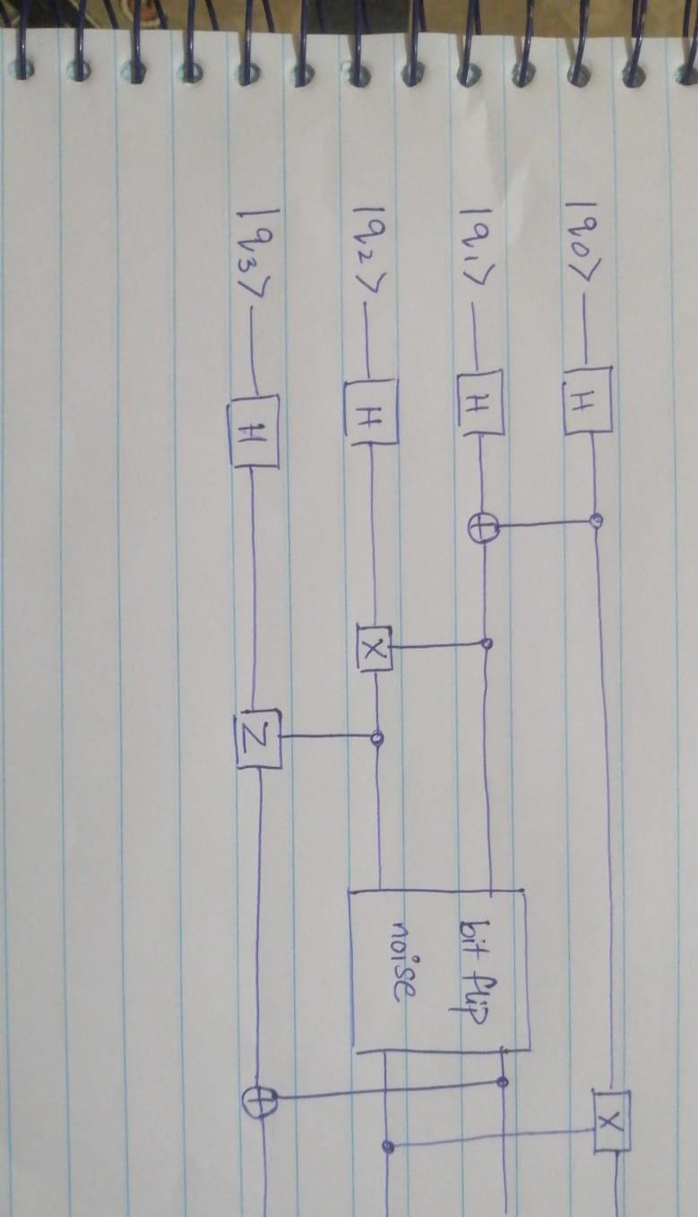

* **Backends:**
  + **Aer Simulator:** This is a noiseless simulator ideal for understanding the perfect circuit behavior without noise.
  + **IBM Quantum Experience Simulator:** This backend incorporates noise models, allowing us to observe the impact of bit-flip errors on the final state probabilities.
* **Visualizing Output:**
  + **State vector Visualization:** The state vector is a complex vector containing probability amplitudes for all possible computational basis states of the qubits. This creates a bar chart where the height of each bar represents the probability of a specific computational basis state being measured
  + **Density Matrix Visualization:** The density matrix is a more compact representation of the quantum state, capturing all the information about the system. Visualization tools can display the density matrix as a heatmap, where the color intensity represents the probability of transitioning between different basis states.